Positional Sound Algorithms for the Sony Playstation2 that Emulate the Sound Produced by the Microsoft XBOX

Bradley J. Reimer
Foundation Technologies
Radical Entertainment Inc.

11 September 2001

TABLE OF CONTENTS

TABLE OF FIGURES 2
INTRODUCTION 3
EXPERIMENTAL PROCESS TO MEASURE THE SOUND VOLUME FALLOFF OVER DISTANCE ON THE XBOX AND PS2 4
Classical Theory 4
ANALYSING THE MEASURED VALUES FOR VOLUME FALLOFF OVER DISTANCE TO DETERMINE A FORMULA THAT ACCURATELY DESCRIBES THE XBOX’S RESULTS 7
MAKING THE PLAYSTATION2’S VOLUME FALLOFF MATCH THE XBOX’S VOLUME FALLOFF 10
CONCLUSION 13
WORKS CITED 14
APPENDIX A: 3D POSITIONAL SOUND LEVELS AT VARYING POSITIONS AND SOURCE FREQUENCIES 15

TABLE OF FIGURES

Figure 1: Volume level test set up for the XBOX and PS2. 4
Figure 2: Comparing the volume falloff over distance on the XBOX (green) and PS2 (blue) with our hypothetical volume falloff (red). Measured using a 1000Hz source sound wave and using varying minimum distances. 6
Figure 3: Comparison between XBOX's volume falloff and the hypothetical volume falloff. Notice the XBOX follows a logarithmic curve, yet never deviates far from the hypothetical values. 7
Figure 4: Comparing the measured volume falloff for the XBOX with our old and new hypothetical volume falloff curves. 10
Figure 5: Volume falloff for the XBOX and PS2 compared to our new and old theories on volume falloff over distance. Measured using a 1000Hz source sound wave and using a minimum distance of 10 units. 12
Figure 6: Volume falloff for the XBOX and PS2 compared to our new and old theories on volume falloff over distance. Measured using a 1000Hz source sound wave and using a minimum distance of 20 units 12
Figure 7: Positional sound levels based on a 5000Hz sine wave on the XBOX (Measured in dB). I have taken readings between 0º and 180º are mirrored them to produce a 360º image. 15
Figure 8: Positional sound levels based on a 2500Hz sine wave on the XBOX (Measured in dB). Readings are actually valid for the entire 360º plane. 16
Figure 9: Positional sound levels based on a 1000Hz sine wave on the XBOX (Measured in dB). I have taken readings between 0º and 180º are mirrored them to produce a 360º image 16
Figure 10: Positional sound levels based on a 100Hz sine wave on the XBOX (Measured in dB). I have taken readings between 0º and 180º are mirrored them to produce a 360º image 17

INTRODUCTION
The head related transform function (HRTF) is the analytical description of a very important sound phenomenon. This is the phenomenon of how the human ear perceives sound based on its three-dimensional location and orientation. A true HRTF is a surprisingly complex algorithm of four variables: three positional dimensions and the frequency of the source sound (Richard Duda, HRTF’s). Being able to realistic emulate sound is incredibly important to video game development as a high degree of realism is important to video game players.

Fortunately, most of the hard work has already been done for us. On the Microsoft XBOX hardware sound processing that creates the appropriate positional sounds occurs automatically. The Sony Playstation2 (PS2), on the other hand, forces us to develop our own positional sound algorithms. The main goal now is to make sure that these algorithms treat positional sounds on the PS2 in the same way as the XBOX treats there’s. Since the most noticeable aspect of a positional sound is its volume at various distances, I will concentrate on making sure the sound volumes match while using an assortment of distance parameters.

Making the PS2’s and XBOX’s sound volume falloff over distance match involves three important steps. First, we must carefully measure the XBOX’s volume falloff information. Next, we must develop a theory that matches the results produced by the XBOX. Finally, we must make sure that the PS2 actually produces sound that follows the new theoretic curve that we will develop.

EXPERIMENTAL PROCESS TO MEASURE THE SOUND VOLUME FALLOFF OVER DISTANCE ON THE XBOX AND PS2
To measure the XBOX’s and PS2’s volume falloff, I have created a test program named the “Radsound testsuite client” that plays a sine wave tone at varying frequencies (100Hz, 1000Hz, 2500Hz, 5000Hz, and 10kHz) and with varying positional settings. For testing the sound volume falloff over distance, we merely specify the sound’s min/max distance (a property of positional sounds), and the actual distance of the sound. After setting these properties, I set up the XBOX and PS2 as in Figure 1. Finally, I use Sonic Foundry’s SoundForge 5.0 to measure the volume information in decibels, which I then record in a table.
Creative Labs SoundBlaster
XBOX
or
PS2
PC Running Windows 2000

Sonic Foundry SoundForge 5.0
Radsound testsuite client
Figure 1: Volume level test set up for the XBOX and PS2.

Classical Theory
Classically, computers model sound falloff over distance by saying that the volume halves every min distance (Equation 1). The relation between decibels and volume is known to be that of Equation 2. Therefore, every min distance, the volume must drop by approximately -Log(0.5) = 3.01dB.

 | = Measured volume level
 | = Distance to the sound source
 | = Min distance property of the positional sound
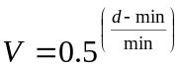
Equation 1: Classical sound theory states that the volume halves every min distance.
 | = Volume level
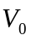 | = Reference volume level
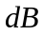 | = Volume in decibels
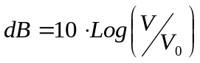
Equation 2: Conversion between volume and decibels.
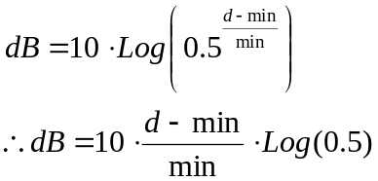
Equation 3: Combining Equations 1 and 2 to give the dB based over distance.
The data collect from the described experiment is displayed in Figure 2. The green lines indicate measurements on the XBOX and the blue lines indicate measurements on the PS2. A third category, the red lines, portrays the predicated sound levels based on our hypothesis that the sound halves every min distance. This line our hypothesis describes is derived in Equation 3.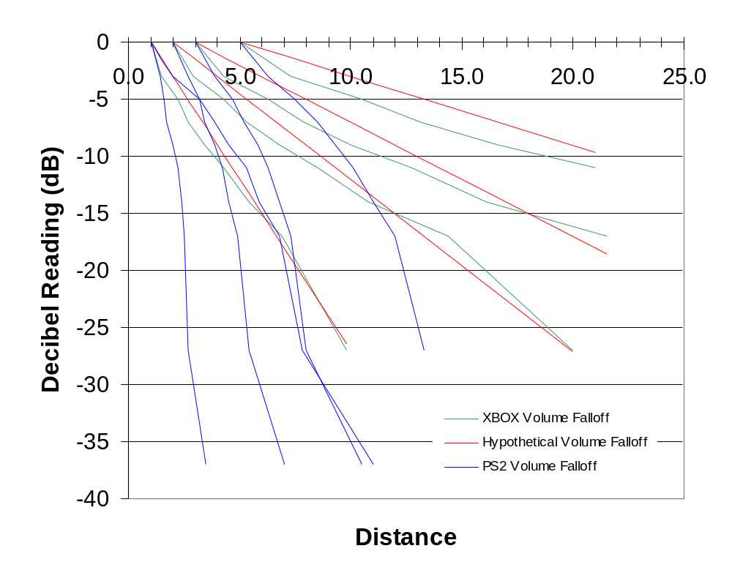
Figure 2: Comparing the volume falloff over distance on the XBOX (green) and PS2 (blue) with our hypothetical volume falloff (red). Measured using a 1000Hz source sound wave and using varying minimum distances.

ANALYSING THE MEASURED VALUES FOR VOLUME FALLOFF OVER DISTANCE TO DETERMINE A FORMULA THAT ACCURATELY DESCRIBES THE XBOX’S RESULTS
A quick look at Figure 2 indicates that our original theory and the actual results produced by the XBOX are very similar. Since our goal, however, is to emulate the XBOX, we must now determine a formula that accurately describes the XBOX’s results. This is a qualitative problem rather than a scientific one as we must merely make the make our results look correct. Figure 3 shows us a close up comparison between the volume falloff on the XBOX’s to our original theory.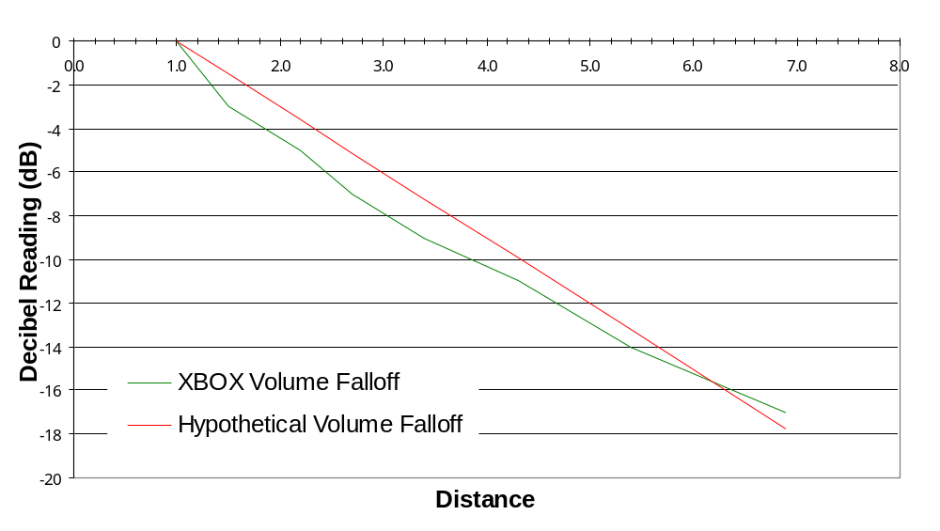
Figure 3: Comparison between XBOX's volume falloff and the hypothetical volume falloff. Notice the XBOX follows a logarithmic curve, yet never deviates far from the hypothetical values.

After playing with the results for a short period of time, we can deduce several properties of the XBOX’s volume falloff:
- The volume falloff follows a curve of the form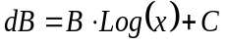, where B and C are constants and x is some function of the distance.
- The volume falloff is always zero (equal to 100% of the volume) when 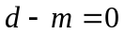.
- The volume falloff is very similar to Equation 3.
- The hypothetical volume falloff and the XBOX’s volume falloff (after repetitive measurements) cross at approximately -16.8dB.
Combining these properties, I obtain Equation 4.
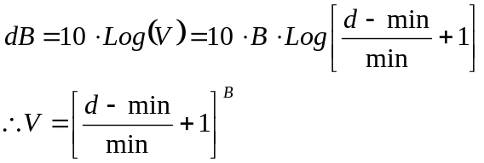
Equation 4: Predicted fit curve for the XBOX volume falloff. A is some constant that is yet to be determined.
Now, we are assuming that the new theory and the new theory cross at –16.8dB. Therefore, we can derive B as in Equation 5.

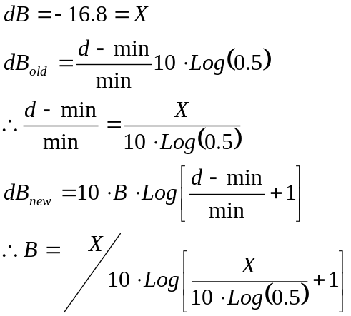
Equation 5: Derivation of the constant A based on the assumption that our old theory and new theory cross at a given volume level X in decibels.
Our new hypothetical curve is drawn alongside the XBOX measurements and our old hypothetical curve in Figure 4. Notice that the new hypothetical curve match the measure values almost exactly.

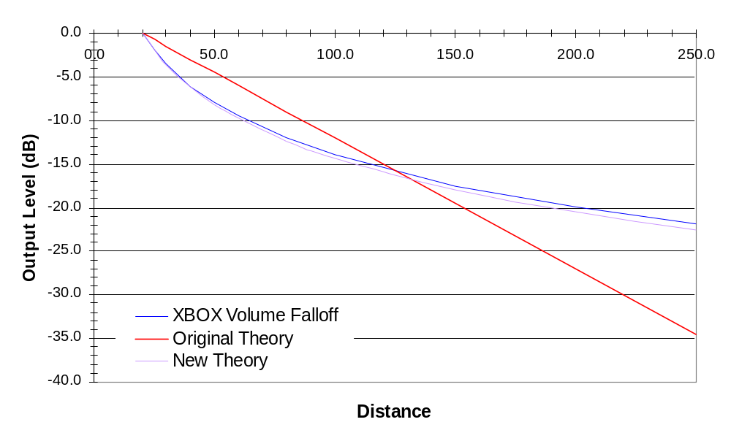
Figure 4: Comparing the measured volume falloff for the XBOX with our old and new hypothetical volume falloff curves.

MAKING THE PLAYSTATION2’S VOLUME FALLOFF MATCH THE XBOX’S VOLUME FALLOFF
Recalling Figure 2, it is obvious that the measured PS2 values do not match the theoretic hypothetical curve that they are designed to represent. Since we now have a new hypothetical curve that matches the XBOX’s volume falloff almost exactly, we must merely find out why the volume output is not conforming to the algorithm that we tell it to.
By carefully examining the results of the previous section, we realize that what we have is actually the volume factor. By multiplying this volume factor with the actual volume emitted, we have the resulting volume level for a particular distance. Now the PS2, on the other hand, requires setting the amplitude factor. The relationship between amplitude and the volume (or power) of a sound wave is given in Equation 6.
 | = Power of a sound wave
 | = Volume of a sound
 | = Amplitude of a sound wave.
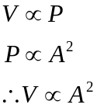
Equation 6: The volume factor is proportional to the square of the amplitude factor.
Unfortunately, the volume factor and amplitude factor are treated as the same thing in our original implementation of positional sounds on the PS2. Hence there is a large discrepancy between the hypothetical values and the actual volume levels measured.
To convert our volume factor to the appropriate amplitude factor, merely use the conversion given in Equation 7.
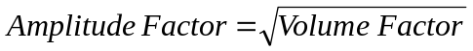
Equation 7: Conversion between amplitude factor and volume factor.
Using this correction, and the volume level given in Equation 4, we force the PS2’s volume falloff over distance to precisely match the XBOX’s volume falloff over distance. Figure 5 and Figure 6 show the new results for minimum distances of 10 and 20 units respectively. Notice how similar the XBOX and PS2 now are compared to Figure 2.
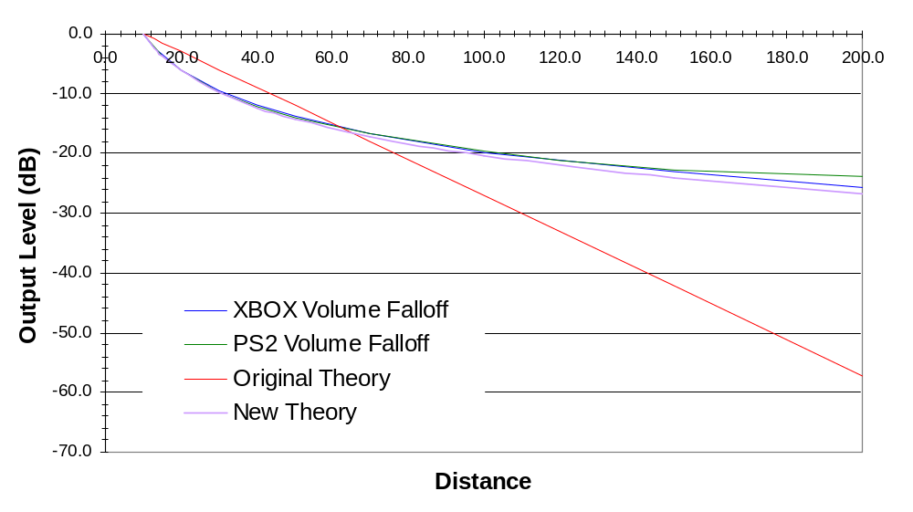
Figure 5: Volume falloff for the XBOX and PS2 compared to our new and old theories on volume falloff over distance. Measured using a 1000Hz source sound wave and using a minimum distance of 10 units.
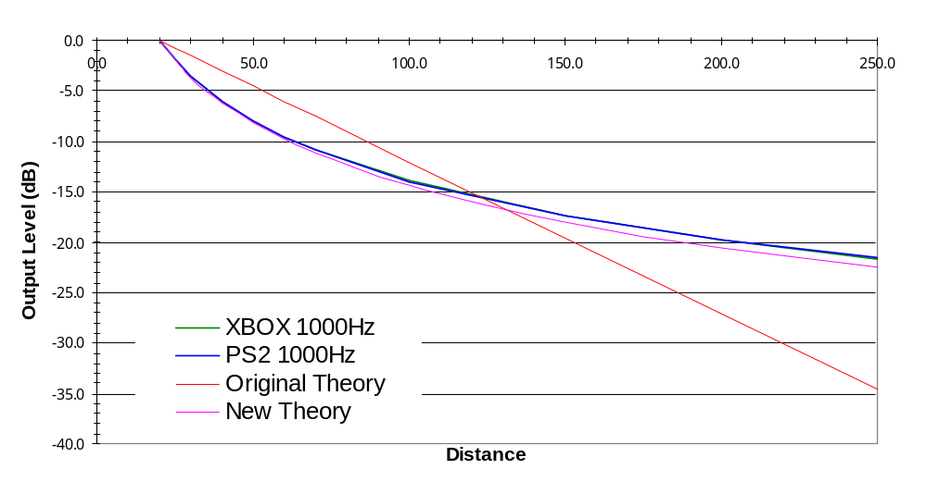
Figure 6: Volume falloff for the XBOX and PS2 compared to our new and old theories on volume falloff over distance. Measured using a 1000Hz source sound wave and using a minimum distance of 20 units

CONCLUSION
Based on the information gathered by analyzing the volume falloff on the XBOX, I recommend implementing two changes to the software listener algorithms for the Playstation2:
- Adjust the volume according to the algorithm:
  - 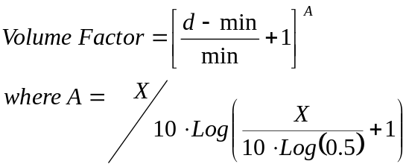
- Scale the hardware value by , instead of just the volume factor.
Once these changes are put into practice, the positional sound on the Sony Playstation2 will closely emulate the positional sound generated by the Microsoft XBOX. Not only will this make tuning easier, but the result sounds will sound on the PS2 will be more realistic than it originally was.

WORKS CITED
Duda, Richard O. “Head Related Transform Functions.” HRTF’s. 6 October 1997. Department of Electrical Engineering
San Jose State University. <http://www.engr.sjsu.edu/~knapp/HCIROD3D/3D_HRTF/3D_HRTF.htm>.
“OpenAL Specification and Reference.” Attenuation By Distance. September 2000. <http://www.openal.org/snapshots/openal/docs/ oalspecs-full/attenuation-by-distance.html>.
XBOX Development Kit. July 28, 2001. Build #3729. Copyright 2000-2001 Microsoft Corporation.

APPENDIX A: 3D POSITIONAL SOUND LEVELS AT VARYING POSITIONS AND SOURCE FREQUENCIES
The following figures indicate the positional sound levels through the left and right speakers produced by the XBOX using a sound source of varying frequency, and position. The data collected for 2500Hz in Figure 8 is based on true 360º measurements. All other figures only use 180º of measurements, and the results are mirrored for the left and right ears. I used this simplification because of the obvious symmetry appearing in Figure 8.

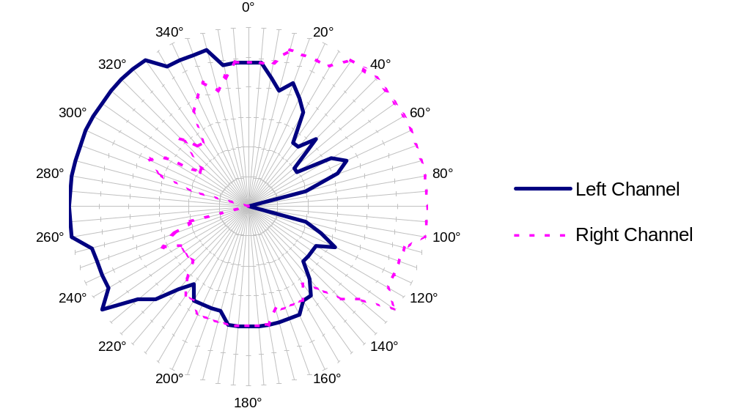
Figure 7: Positional sound levels based on a 5000Hz sine wave on the XBOX (Measured in dB). I have taken readings between 0º and 180º are mirrored them to produce a 360º image.
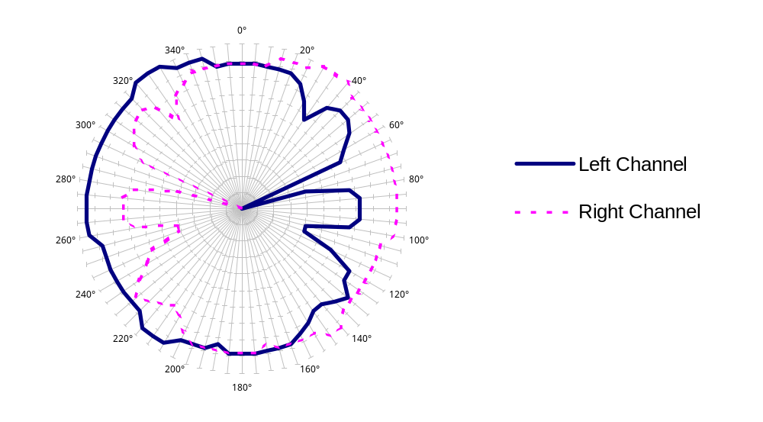
Figure 8: Positional sound levels based on a 2500Hz sine wave on the XBOX (Measured in dB). Readings are actually valid for the entire 360º plane.
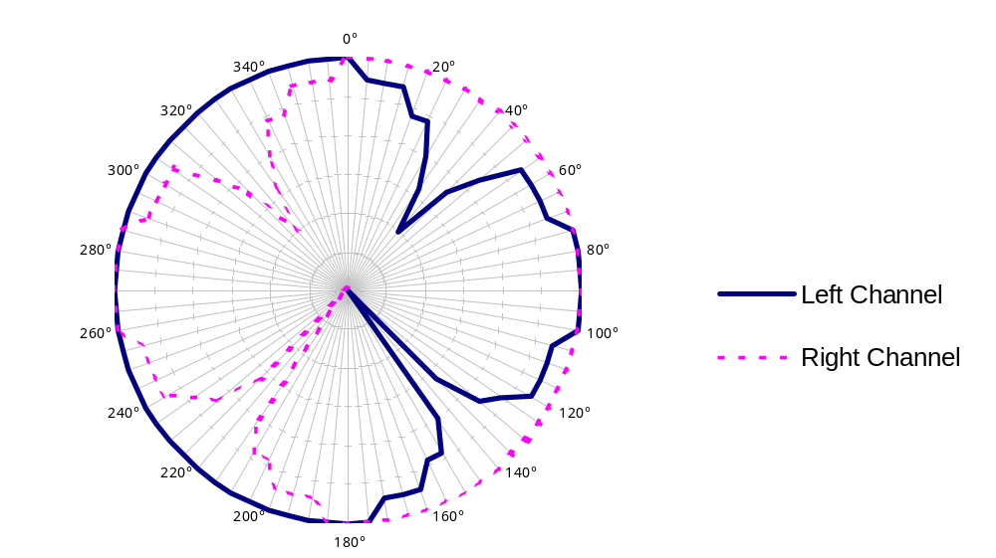
Figure 9: Positional sound levels based on a 1000Hz sine wave on the XBOX (Measured in dB). I have taken readings between 0º and 180º are mirrored them to produce a 360º image
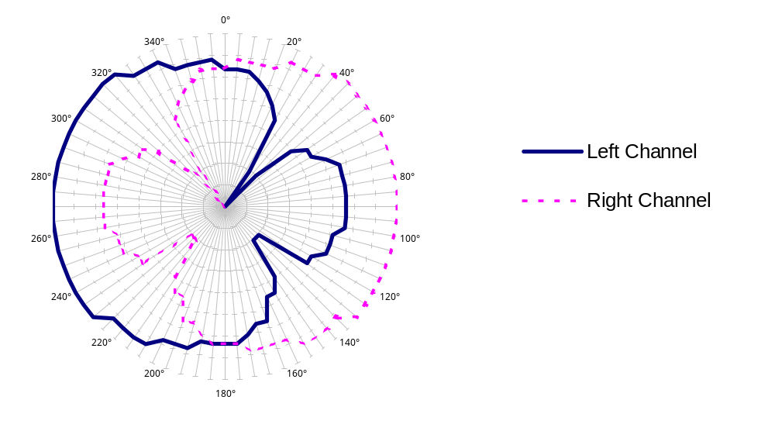
Figure 10: Positional sound levels based on a 100Hz sine wave on the XBOX (Measured in dB). I have taken readings between 0º and 180º are mirrored them to produce a 360º image

